## MTG Deck List (Red / Green)

**Green**

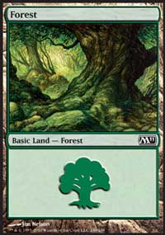

Land:

Forest – 10

Instant:

Symbiosis – 3

Summon:

Pouncing Jaguar – 3

Blanchwood Treefolk – 3

Winding Wurm – 3

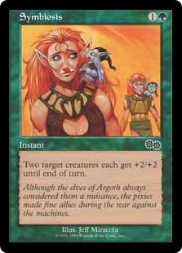

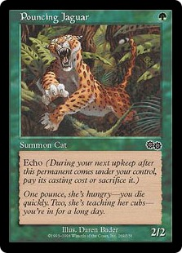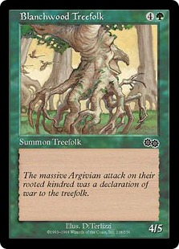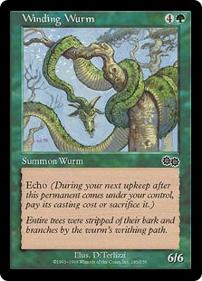

**Red**

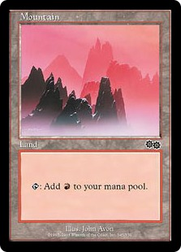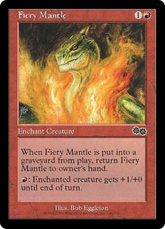

Land:

Mountain – 14

Enchant Creature:

Fiery Mantle – 3

Instant:

Shower of Sparks – 3

Heat Ray – 3

Sorcery:

Arc Lightning – 3

Summon:

Goblin Patrol – 3

Goblin War Buggy – 3

Goblin Raider – 3

Viashino Outrider – 3

